**Experiment No. 2.2**

**Student Name: Rishav Kumar UID: 22MCC20039**

**Branch: MCA - CCD Section/Group: MCD-1/ Grp A**

**Semester: III Date of Performance: 29th Sep 23**

**Subject Name: Business Analytics Subject Code: 22CAH-703**

1. **Aim/Overview of the practical:**

To create, alter, and drop databases, tables, views, functions and indexes.

**2. Code for practical:**

* To create a table in SQL use command

***create table Salary(ID int, Name varchar(20), Department varchar(20), Salary int);***

* It will create a table with same columns.

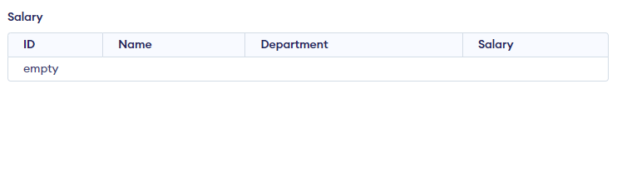

* To insert a record, use following command

***insert into Salary values(1001, "Rishav Kumar", "SDE", 20000);***

* To add a column, we use ALTER

***Alter table Salary add Address;***

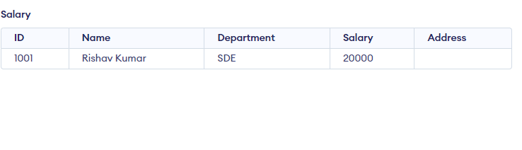

* A new column will be created.
* To Rename table name, use ALTER

***Alter table Salary rename column Address to EMP;***

* It will rename Address to EMP.

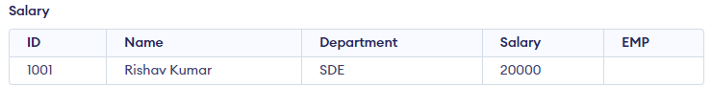

* Top drop a table use Drop

***Drop table Salary***

* To create a view, use command

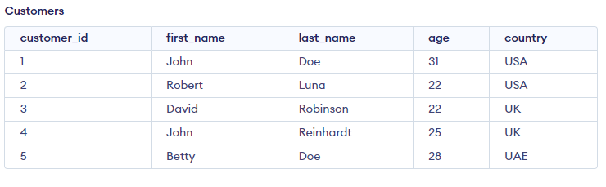

***CREATE VIEW newView AS SELECT first_name, last_name FROM Customers WHERE age>22;***

* To see the view, use

***Select * from newView;***

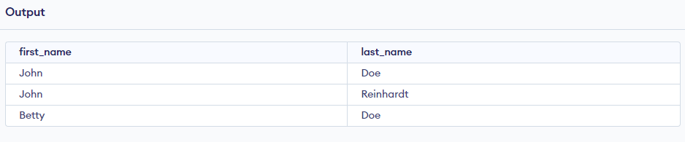

* To create index on a selected column use

***CREATE INDEX idx _last_name ON Customers (last_name);***

* To create a function,

***CREATE FUNCTION get_customer_info(customer_id INT)***

***RETURNS TABLE (full_name TEXT, country TEXT)***

***AS***

***$$***

***BEGIN***

***RETURN QUERY***

***SELECT first_name || ' ' || last_name, country***

***FROM customers***

***WHERE customer_id = get_customer_info.customer_id;***

***END;***

***$$;***

* It will return full name of employee.

***SELECT * FROM get_customer_info(2);***

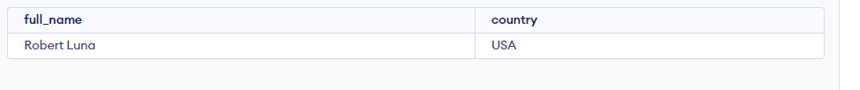

**************************************** **THE END** ***********************************************